# The Boring Company

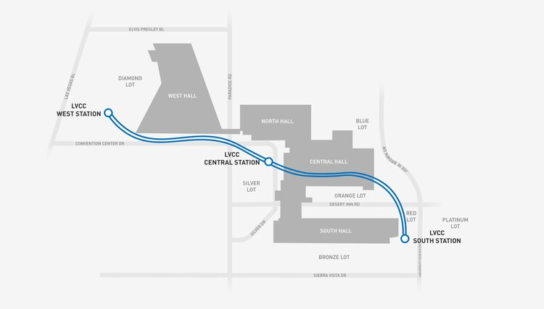

*The LVCC (LAS VEGAS CONVENTION CENTER) Loop system — a three-station transportation system consisting of 1.7 miles of tunnel — was built in approximately one year. LVCC Loop's cost was approximately $47M (firm fixed pricing) for the two tunnels and three stations (two surface and one subsurface).*

The Boring Company hired you to write an algorithm that calculates the **minimum budget** required to **connect all districts** in Las Vegas to the **existing tunnel system**.

You are given the **network of districts** (some of them are connected to the tunnel system) along with the **estimated connection costs** between some districts.

A district can only be connected to the network via a direct connection with an already connected district.

## Input

* On the first line, you will receive an integer – n – number of distrcits (numbered from 0 to n - 1).
* On the second line, you will receive an integer – e – number of connections between the districts.
* On the third line, you will receive an integer – p – number of **already connected districts** to the tunnel system.
* On the next e lines, you will receive a connection in the following format: "{first district} {second district} {estimated cost}".
* On the next p lines, you will receive already connected districts in the following format: "{first district} {second district}".

## Output

* Print "Minimum budget: {minBudget}" on the console.

## Constraints

* n will be in the range [1… 20].
* e will be in the range [1… 30].
* p will be in the range [1… 10].
* estimated cost will always be in the range [1… 200].

## Examples

|  |  |
| --- | --- |
| **Input** | **Output** |
| 4  5  2  0 1 9  0 3 4  3 1 6  3 2 11  1 2 5  0 3  3 2 | Minimum budget: 5 |
| 8  16  1  0 1 4  0 2 5  0 3 1  1 2 8  1 3 2  2 3 3  2 4 16  2 5 9  3 4 7  3 5 14  4 5 12  4 6 22  4 7 9  5 6 6  5 7 18  6 7 15  0 3 | Minimum budget: 36 |